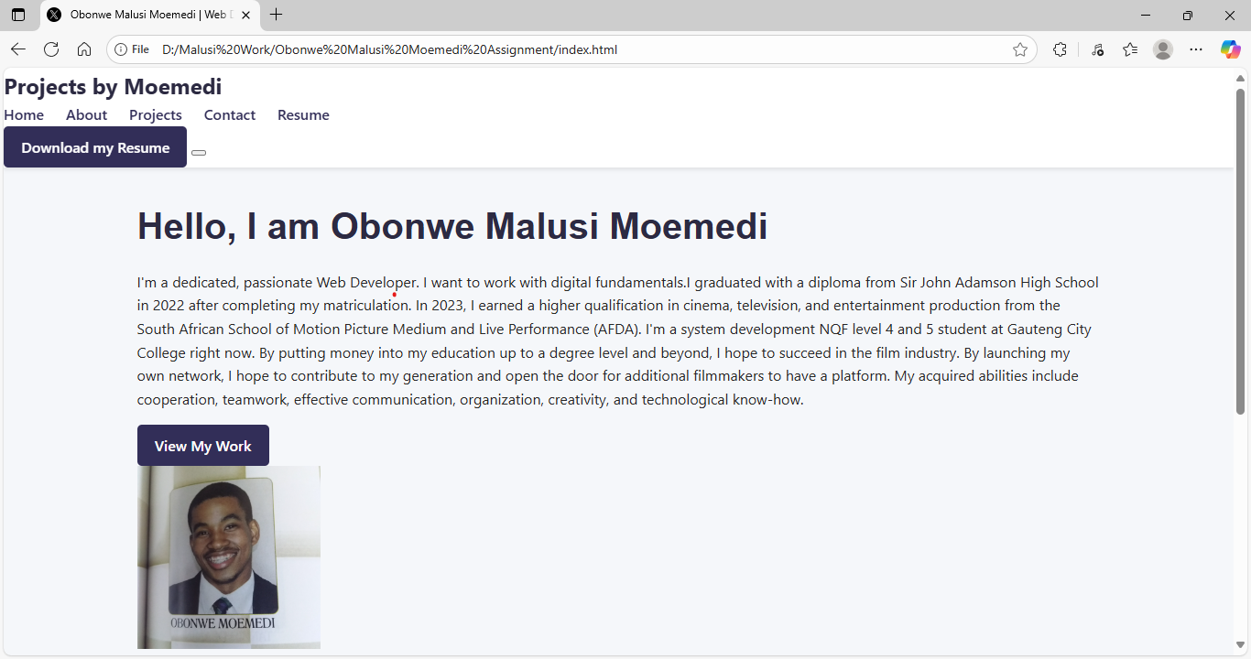

This is the home page that shows the introduction and the profile picture.

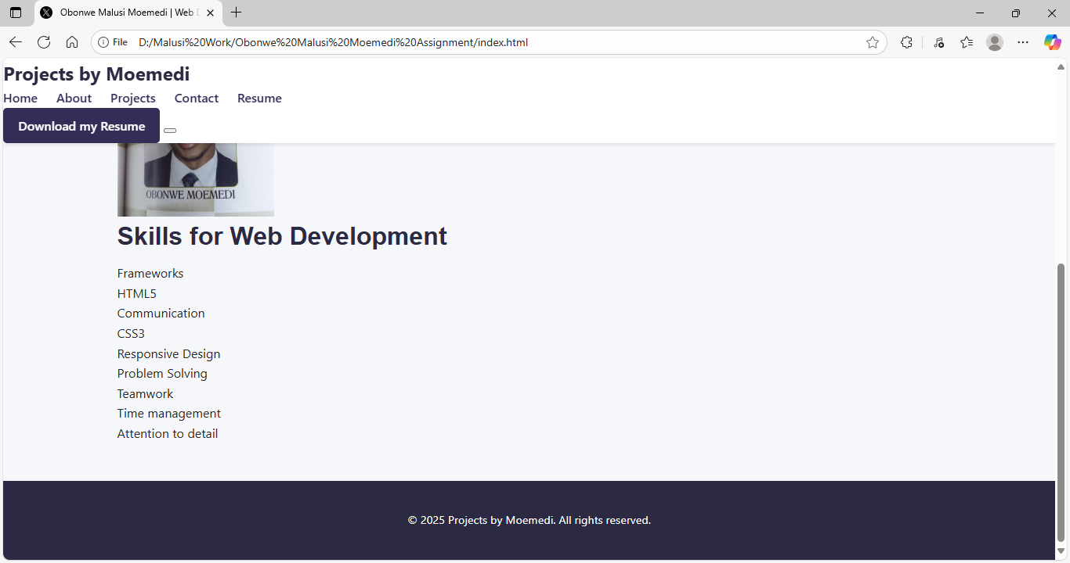

This page indicates the skills for web development that include CSS3, HTML, Responsive Design and etc.

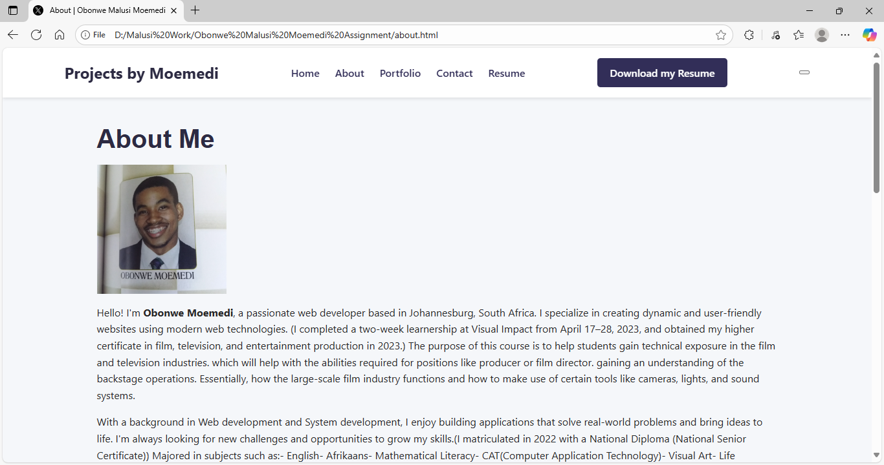

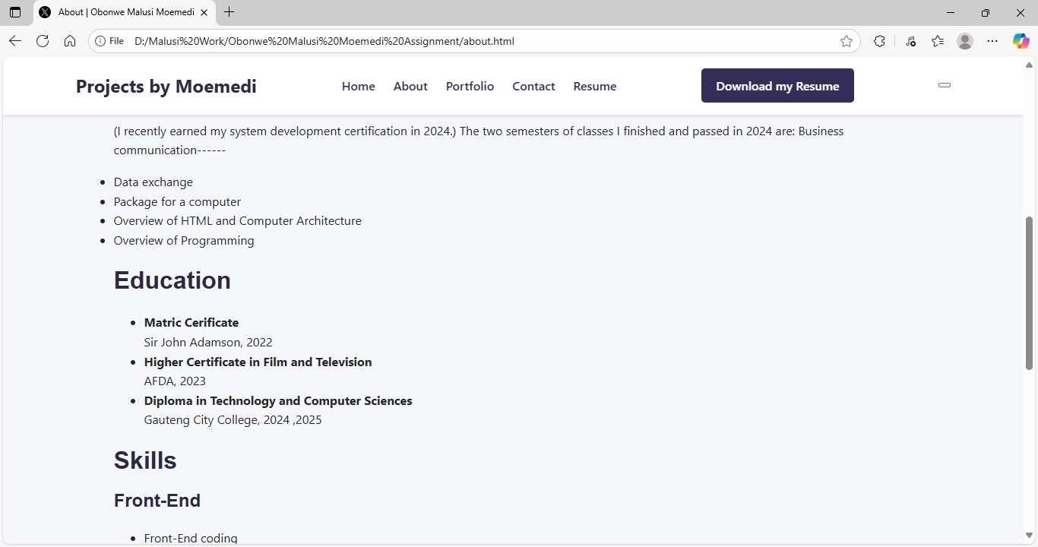

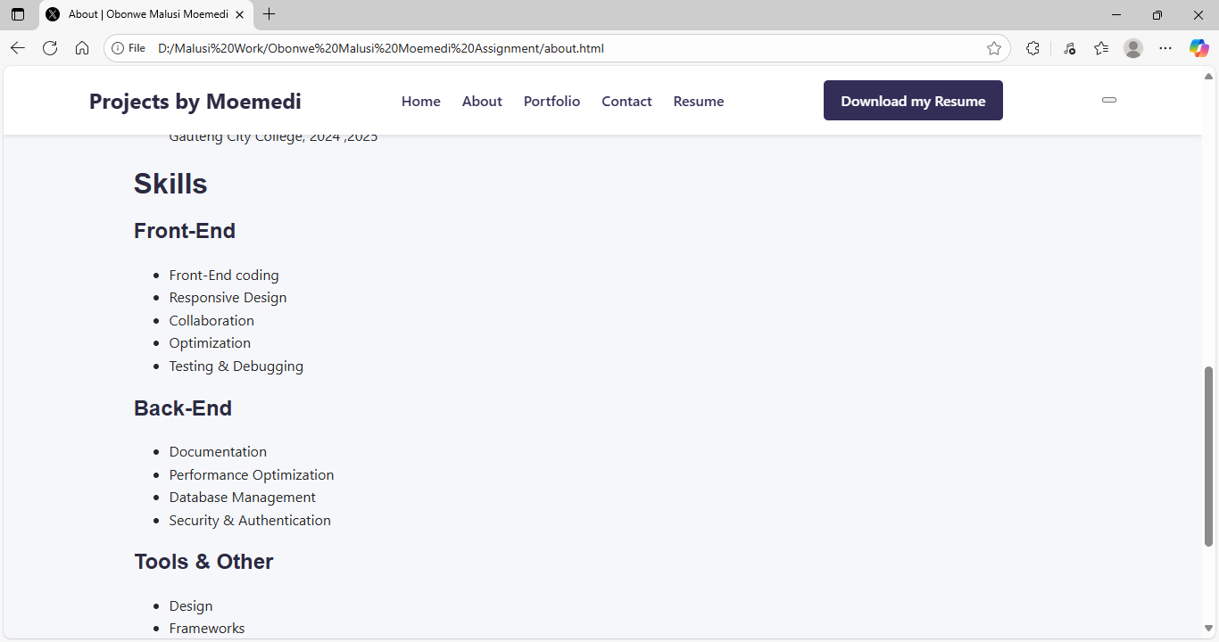

The about pages indicate the skills from Front-End, Back-End and the tools with the education being included and description in the beginning of the about page.

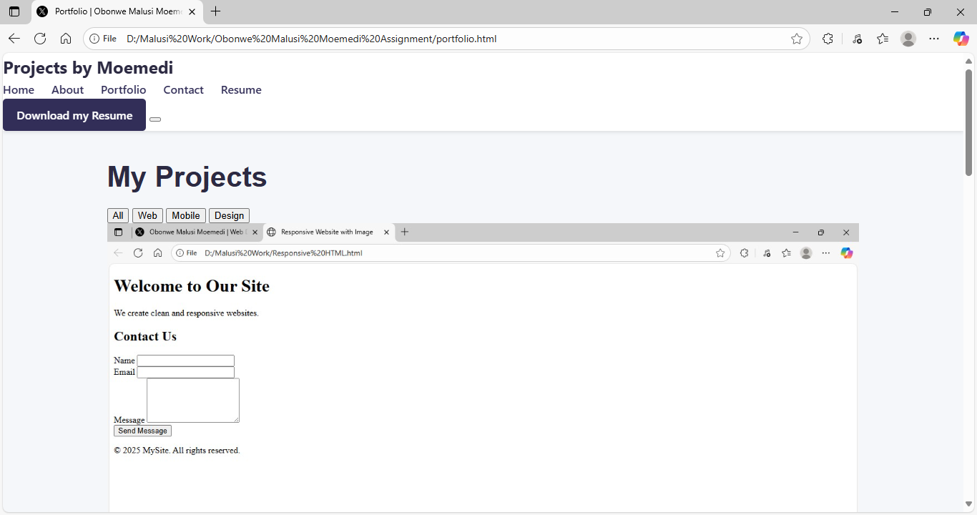

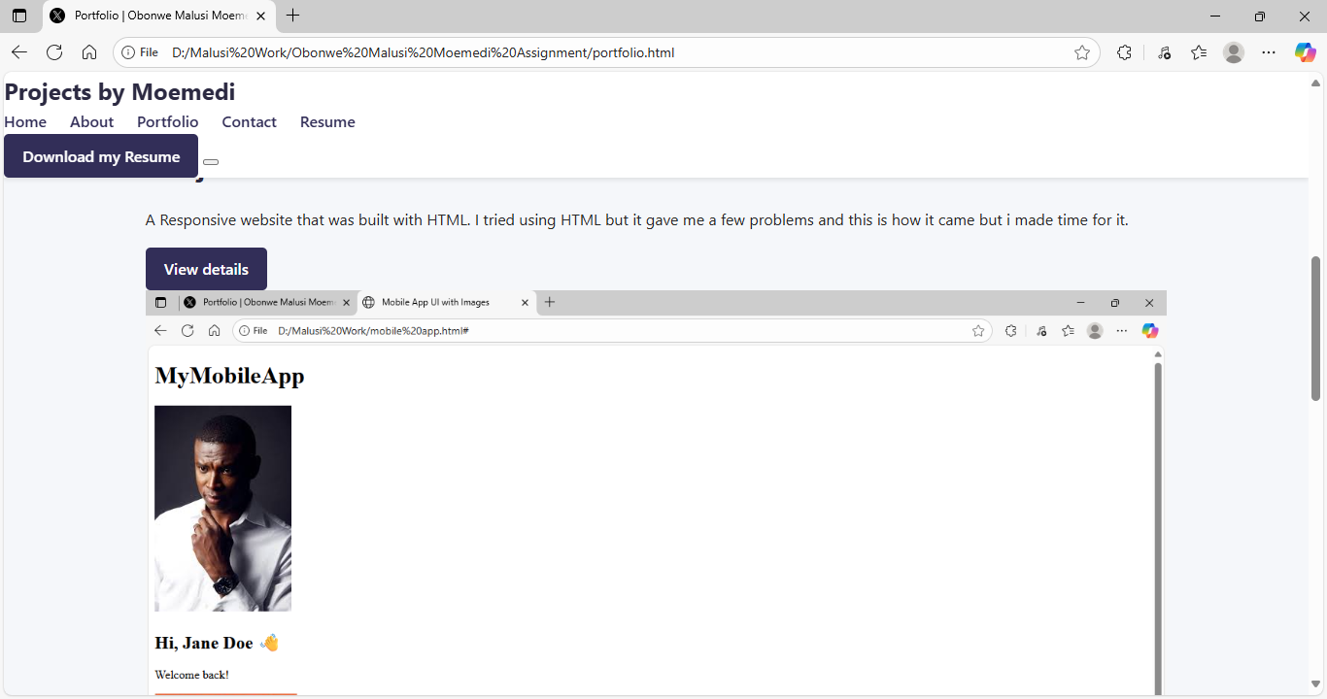

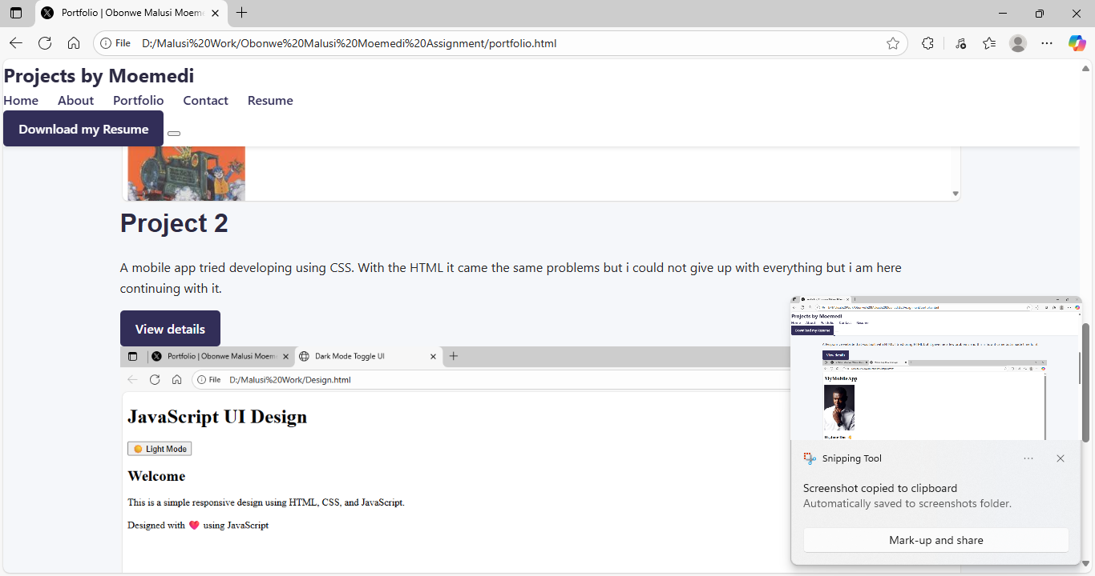

This all indicates the projects I tried to develop with HTML, CSS and JavaScript.

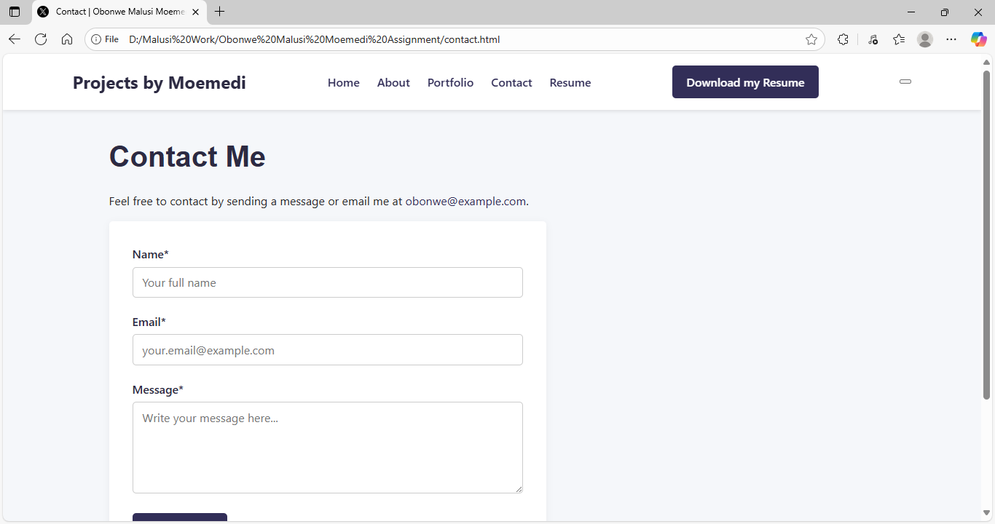

In conclusion, This shows where you can contact us with adding your name, email and Message. You will further click the resume that indicates the resume shown.